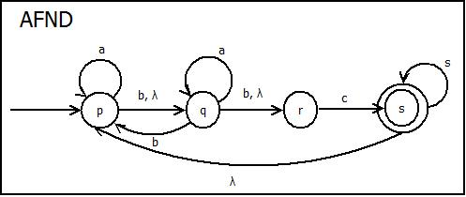**Tabla de Transición AFND**

|  |  |  |  |  |
| --- | --- | --- | --- | --- |
|  | **a** | **b** | **c** | **λ** |
| **→p** | **p** | **q** | **_** | **q** |
| **q** | **q** | **p, r** | **_** | **r** |
| **r** | **_** | **_** | **s** | **p** |
| **\*s** | **s** | **_** | **_** | **_** |

**Proceso**

|  |  |  |  |
| --- | --- | --- | --- |
|  | **a** | **b** | **c** |
| **→A = {p} U {q r}** | B = {p q} U {r} | C = {p q r} | D = {s} |
| **B = {p q} U {r}** | B = {p q} U {r} | C = {p q r} | D = {s} |
| **C = {p q r}** | B = {p q} U {r} | C = {p q r} | D = {s} |
| **\* C = {p q r}** | D = {s} | _ | _ |

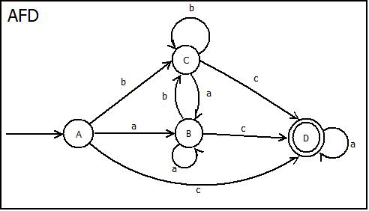**Tabla de Transición AFD**

|  |  |  |  |
| --- | --- | --- | --- |
|  | **A** | **b** | **c** |
| **→A** | **B** | **C** | **D** |
| **B** | **B** | **C** | **D** |
| **C** | **B** | **C** | **D** |
| **\*D** | **D** | **_** | **_** |